PROJECT TITLE
MINI PROJECT REPORT
Submitted by

Umesh Tummepalli [ RA2311030010189] Aditya Chauhan [ RA2311030010201] Rohan Shubam [ RA2311030010200]

Under the Guidance of

Dr. N. Senthamarai
21CSS201T – COMPUTER ORGANIZATION AND ARCHITECTURE

DEPARTMENT OF NETWORKING AND COMMUNICATIONS



FACULTY OF ENGINEERING AND TECHNOLOGY SCHOOL OF COMPUTING
SRM INSTITUTE OF SCIENCE AND TECHNOLOGY KATTANKULATHUR
NOVEMBER 2024

1

Microprocessor based water level controller

OBJECTIVE:

The objective of this project is to create a water level controller using an Arduino Nano that automatically maintains the desired water level in a tank by controlling a water pump.

ABSTRACT:

This project presents the design and implementation of a microcontroller-based water level controller using an Arduino Nano. The system utilizes an ultrasonic sensor to monitor water levels in a tank and a relay module to control a water pump. The controller ensures the maintenance of a preset water level, providing a cost-effective and automated solution for water management in various applications.

INTRODUCTION:

Water is a vital resource with applications spanning from domestic use to industrial processes. Ensuring the availability of an adequate and controlled water supply is crucial for efficiency and convenience. In various applications such as agriculture, aquaculture, and domestic water management, maintaining the desired water level in a tank or reservoir is of paramount importance.

This project addresses the need for a reliable and cost-effective solution to automate the management of water levels. The primary objective is to design and implement a water level controller that can efficiently monitor and regulate water levels in a tank. The system incorporates an Arduino Nano microcontroller, an ultrasonic sensor, and a relay module to control a water pump. By doing so, it offers a versatile and practical solution for a range of applications where water level maintenance is essential. This project aims to simplify water level control, improve resource management, and reduce the manual effort required for such tasks.

HARDWARE/SOFTWARE REQUIREMENTS:

Hardware Requirements:

- Arduino Nano: The microcontroller that forms the core of the system.
- Ultrasonic Sensor (e.g., HC-SR04): To measure the water level in the tank.
- Relay Module: To control the water pump.
- Water Pump: To regulate the water level in the tank.
- 9V Battery with Connector: Power source for the Arduino Nano (for testing and prototyping).

- Micro USB Cable: Used for programming the Arduino Nano.
- Circuit Board: To assemble and connect the components.
- Connecting Wires: For wiring the components and connections.
- Tank or Reservoir: The physical container for holding the water.

Software Requirements:

- Arduino IDE: To write, compile, and upload the firmware to the Arduino Nano.
- Arduino Libraries (if necessary): Depending on the specific components used, you may need libraries for ultrasonic sensors or other peripherals.
- Programming Language: The firmware for the Arduino Nano is typically written in (C/C++).

CONCEPTS/WORKING PRINCIPLE
The Microprocessor-Based Water Level Controller is designed to automate the process of monitoring and maintaining water levels in tanks or reservoirs. The fundamental concept behind this system lies in the integration of sensors and a microcontroller to create an intelligent and efficient water level management mechanism.

Concept:

At its core, the system utilizes ultrasonic sensors to measure the water level inside the tank. These sensors emit ultrasonic waves and measure the time it takes for the waves to bounce back after hitting the water surface. This information is then processed by a microcontroller, in this case, the Arduino Nano, which compares the measured water level with a predefined threshold value. If the water level falls below the threshold, indicating insufficient water, the microcontroller activates a relay module connected to a water pump. The pump starts, replenishing the water in the tank until the desired level is reached. Once the water level reaches the specified limit, the microcontroller deactivates the pump, ensuring that the tank does not overflow.

Working Principle:

The microprocessor-based water level controller is designed to automate the management of water levels in a tank or reservoir. The system relies on the following key concepts and working principles:
- Ultrasonic Distance Sensing: The system uses an ultrasonic sensor, typically an HCSR04, to measure the distance between the sensor and the water surface. The sensor generates high-frequency sound waves and measures the time it takes for the sound waves to
bounce off the water surface and return. Using the speed of sound, it calculates the distance between the sensor and the water surface.

- Data Acquisition: The ultrasonic sensor continuously sends distance measurements to the Arduino Nano, which processes this data in real-time. The Arduino uses the measured
distance to determine the current water level in the tank.

- Threshold-Based Control: The system is programmed with predefined water level
thresholds (e.g., high and low levels). Based on the measured water level, the Arduino Nano makes control decisions to maintain the water level within the desired range.

- Relay Control: When the water level falls below a set threshold, indicating the need to add water, the Arduino activates a relay module. The relay, in turn, switches on the water pump to fill the tank.

- Pump Shutdown: Once the water level reaches the upper threshold, the Arduino
deactivates the relay, turning off the water pump. This prevents overfilling of the tank.

- Safety Features: The system may incorporate safety features to prevent overflows and handle exceptional cases. For example, it can include a time-based cutoff to prevent the pump from running continuously.

- Power Supply: The system can be powered by a 9V battery or another suitable power source. The power supply must be stable to ensure continuous operation.

APPROACH/METHODOLOGY/PROGRAMS:

- Arduino Nano Setup:
  - Connect the Arduino Nano to your computer using the micro USB cable for programming and initial testing.
  - Program the Arduino Nano with the water level control firmware using the Arduino IDE.
  - Ensure a stable power supply for the Arduino Nano during operation, such as a 9V battery.

- Ultrasonic Sensor Setup:
  - Connect the ultrasonic sensor to the Arduino Nano:
  - VCC of the sensor to 5V on the Arduino Nano.
  - GND of the sensor to GND on the Arduino Nano.
  - Trigger pin of the sensor to a digital pin (e.g., D2 on Arduino Nano).
  - Echo pin of the sensor to another digital pin (e.g., D3 on Arduino Nano).

- Relay Module Connection:
  - Connect the relay module to the Arduino Nano:

  - Connect the VCC and GND of the relay module to the 5V and GND pins on the Arduino Nano.
  - Connect the signal pin of the relay module (e.g., IN1) to a digital pin on the Arduino Nano (e.g., D4).

- Water Pump Connection:
  - Wire the water pump to the relay module.
  - The relay module acts as a switch, enabling or disabling the power to the water pump based on the control signals from the Arduino Nano.

FLOWCHART:
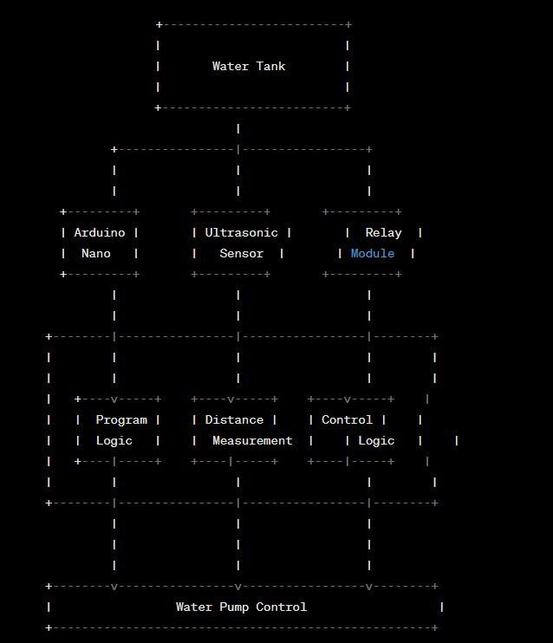

- The "Water Tank" represents the physical container for holding the water.
- The "Arduino Nano" is the microcontroller responsible for reading data from the
"Ultrasonic Sensor," processing it using the "Program Logic," and controlling the "Relay Module."
- The "Ultrasonic Sensor" measures the distance to the water surface in the tank.
- The "Relay Module" is used to control the "Water Pump."
- The "Program Logic" includes the firmware for the Arduino Nano, which processes sensor data, makes control decisions, and implements safety features.
- The "Water Pump Control" is where the control logic activates or deactivates the water pump based on the water level measurements.

OUTPUT:
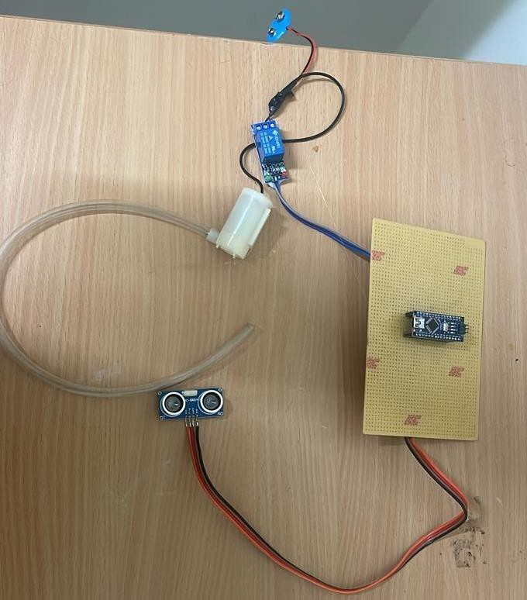

CONCLUSIONS:
In conclusion, the water level controller effectively maintains the desired water level, optimizing resource utilization and reducing manual intervention.

REFERENCES:
https://www.instructables.com/Automatic-Water-Level-Indicator-and-Controller-Usi/

